# OUTPUTS

1st Question

2nd Question

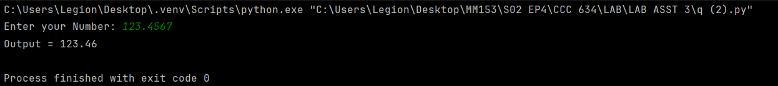

3rd Question

4th Question

5th Question

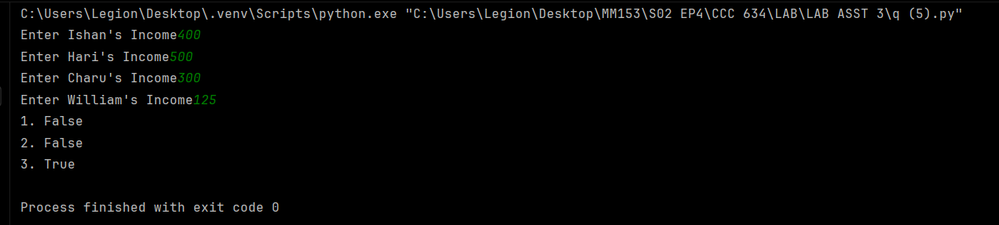

6th Question

7th Question

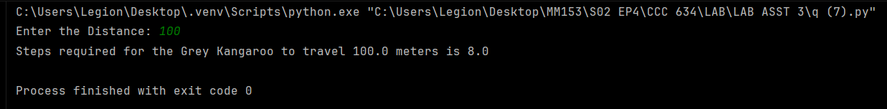

8th Question

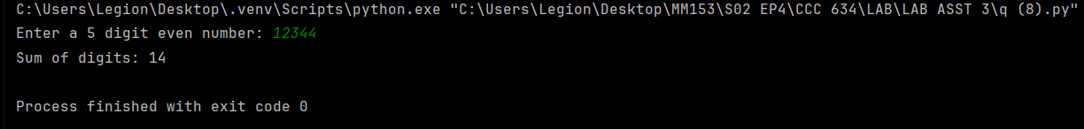

9th Question

10th Question

11th Question

12th Question

13th Question

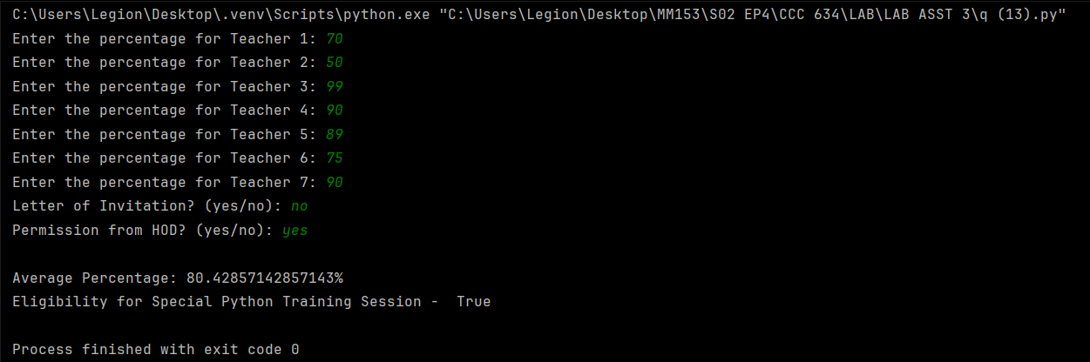

14th Question

15th Question

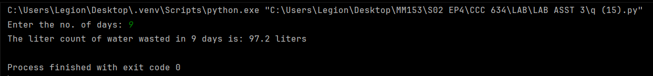

16th Question

17th Question

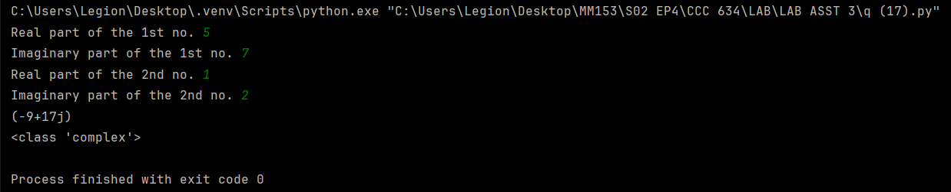

18th Question

